Comparative Analysis of Lightweight CNN Architectures for Real-Time Deepfake Detection
Ramil Zohrabli ,Chung-Ang University, School of Computer Science and Engineering
Seoul, South Korea
Email:ramilzohrabli310306@gmail.com

Abstract— This paper systematically analyzes three lightweight CNN architectures—MobileNetV3-Small, EfficientNet-B0, and ResNet18—for real-time deepfake detection under a unified preprocessing, training, and evaluation pipeline. Beyond reporting numerical differences in accuracy, precision, recall, F1-score, and throughput, we explicitly investigate architectural factors that shape model behavior, including residual connections, depthwise-separable convolutions, squeeze-and-excite blocks, compound scaling, and the effective number of trainable parameters exposed during transfer learning. On the Google DeepFake Detection (DFD) dataset, all models are fine-tuned from ImageNet and benchmarked on an NVIDIA RTX 3060 GPU. ResNet18 achieves the strongest overall performance (92.5% accuracy, 92.8% F1-score, 97.7% recall for fake frames) with moderate latency (~0.56 ms/frame, 1801 FPS), while MobileNetV3-Small attains a competitive F1-score (90.4%) and offers the best speed–accuracy trade-off (~0.46 ms/frame, 2223 FPS). In contrast, EfficientNet-B0—despite having the largest total parameter count—obtains the lowest accuracy (87.8% with 87.97? F1-score) and the slowest inference (~1.20 ms/frame, 880 FPS), largely because only 0.06% of its weights are trainable in our setup, causing the backbone to act as an almost frozen feature extractor. Through joint analysis of confusion matrices, learning curves, parameter statistics, and latency, we show that the interaction between architectural design and trainable capacity is a stronger predictor of deepfake detection performance than raw model size alone. The same methodology is later extended to the Celeb-DF dataset to examine how these conclusions generalize to more challenging, high-quality forgeries and to derive practical guidelines for selecting lightweight CNN backbones in real-time deepfake detection systems.
Keywords—deepfake detection, lightweight CNNs, MobileNetV3, EfficientNet, ResNet18, multi-dataset evaluation.

INTRODUCTION
The rapid advancement of generative models like GANs and diffusion-based architectures has greatly increased deep-fake content creation, and this has become widely accessible and realistic. These deep-fake contents can lead to misinformation, harassment, and different kinds of threats which make deep-fake detection and analysis so important. Although complex deepfake detection systems with heavy architectures — XceptionNet, EfficientNet-L variants, or transformer-based models — learn deepfake easily and achieve high accuracy scores, their complexity and hardware limitations do not allow them to be performable and deployable on edge devices and consumer platforms. Instead, several lightweight convolutional neural networks (CNNs) — including MobileNetV3, EfficientNet-B0, and ResNet18 — performs well on these kinds of scenarios with considerably lower computational cost and high-throughput facial forgery detection
There are a limited number of comparative studies focusing on lightweight CNN architectures. Existing studies often elaborate on heavy models which are costly and unusable for real-time environments. In addition, other studies do not always examine the reason behind why certain architectures outperform others, which is the main part of understanding the inner side of deep-fake detection models.
This study is mainly focused on comparative analysis of lightweight CNN architectures — MobileNetV3-Small, EfficientNet-B0, and ResNet18 — using the same training pipelines for each of them and evaluating their differences in performance across two structurally different deep-fake datasets
Here are three distinct “small” CNN architectures:
- MobileNetV3-Small – optimized for mobile inference through depthwise separable convolutions, squeeze-and-excitation, and hard-swish activations.
- EfficientNet-B0 – a compound-scaled baseline using MBConv blocks with SE, designed for parameter efficiency.
- ResNet18 – a classic residual CNN with 3×3 convolutions and identity skip connections.
In this research paper, all three models are fine-tuned on two different deep-fake datasets. The results and analysis come from identical training for all three models. The study focuses on targetable research questions below
RQ1. Under a unified face-level pipeline, how do MobileNetV3-Small, EfficientNet-B0, and ResNet18 compare in terms of deepfake detection performance on the DFD dataset (accuracy, precision, recall, F1-score)?
RQ2. How do architectural properties—parameter count and fraction of trainable parameters—affect convergence behavior and overfitting on a relatively small deepfake dataset?
RQ3. What accuracy–latency trade-off does each architecture achieve on GPU, and which models clearly satisfy real-time constraints for video-rate inference?
The remaining part of introduction will focus on the questions for the DFD
- Under a unified face-level pipeline, how do MobileNetV3-Small, EfficientNet-B0, and ResNet18 compare in terms of deepfake detection performance on the DFD dataset (accuracy, precision, recall, F1-score)?
- How do architectural properties—parameter count and fraction of trainable parameters—affect convergence behavior and overfitting on a relatively small deepfake dataset?
- What accuracy–latency trade-off does each architecture achieve on GPU, and which models clearly satisfy real-time constraints for video-rate inference?

RELATED WORK
Deepfake detection has been studied extensively over the years. Rossler et al. introduced FaceForensics++ dataset and showed that CNNs like XceptionNet can successfully detect manipulated inputs with high performance and accuracy. However, this approach results with high computational costs. Other studies focused on temporal cues connected with recurrent networks or 3D CNNs. Also, recent methodology focused on employment of ViTs or multi-stream architectures
There are several datasets that have been released for measurement and benchmark of detection systems. These datasets include Google Deepfake Detection dataset (DFDC), Celeb-DF v2, etc c. Celeb-DF is particularly challenging because of high-quality deepfakes generated with improved pipelines, conclude with fewer visible artifacts in sample frames.
There is also growing interest in lightweight deep-fake detectors. These kinds of architectures can be suitable for mobile devices with minimal costs. For example, MobileNet-based systems maintain reasonable performance and accuracy with reduced computational costs. However, existing research areas do not focus on understanding architecture and capacity that play a very important role in performance.
If we delve into the architectural side, MobileNetV3 introduces inverted residual blocks with squeeze-and-excitation and efficient activation functions (hard-swish) to improve latency on mobile CPUs. EfficientNet uses compound scaling of depth, width, and resolution on top of MBConv blocks to achieve strong accuracy–parameter trade-offs. ResNet architectures use identity skip connections to train deeper networks without vanishing gradients.
In contrast to another studies, this paper directly refers to comparison of these lightweight CNN families under controlled setup and explicitly analyses architectural design by relating it to performance and training capacity.

DATASETS AND PREPROCESSING
- Face-Level DFD Dataset
The Google/Jigssaw Deepfake Detection dataset (DFD) contains 363 original and 3068 manipulated videos. The main artifacts are often noticeable around the face region. This makes the dataset relatively easier compared to other highly synthesized datasets
For this work, the study focuses on the Kaggle mirror “Deep Fake Detection (DFD)” and construct a frame-level face dataset as follows:
1. Face detection: For each video, a face detector is applied to every frame.
2. Frame sampling: 8 frames are sampled uniformly per video
3. Cropping and resizing: detected faces are cropped and resized to 224×224 pixels
4. Split construction: faces are assigned into train/validation/test splits while balancing the number of real and fake samples in each split.
DFD Face-level Dataset Statistics
Splits | Real | Fake | Total
Train | 1778 | 1778 | 3556
Val | 381 | 393 | 774
Test | 397 | 388 | 785
Total | 2556 | 2559 | 5115

- Celeb-DF v2 Image Dataset
Celeb-DF v2 is a high-quality deepfake video dataset containing 590 real and 5 639 synthetic videos with substantially reduced visual artifacts compared to earlier datasets such as FaceForensics++ and DFD. In this work, we use a frame-level image version of Celeb-DF v2 where face crops are pre-extracted and resized.
In this work, the research focused on frame-level image version of Celeb-DF v2 that is pre-processed and resized
Final dataset contains 101031 images:
Celeb-DF v2 Face-Level Dataset Statistics
Splits | Real | Fake | Total
Train | 40288 | 40536 | 80824
Val | 5036 | 5068 | 10104
Test | 5036 | 5067 | 10103
Total | 50360 | 50671 | 101 031

Unlike DFD, Celeb-DF v2 frames are harder to detect and distinguish with the human eye. This makes it very strong benchmark for realistic analysis
- Preprocessing and Augmentation
All face crops from datasets are normalized, and the used statistics is ImageNet. The images resized in 224x224 format. During training part, data augmentation applied to all 3 models:
- random resized cropping
- horizontal flip
- color jitter
- Gaussian blur
- small random rotations
This method is for improving robustness to several common content features like compression artifacts.

CNN ARCHITECTURES AND TRAINING CONFIGURATION
- MobileNetV3-Small
As mentioned previously, MobileNetV3-Small is a compact mobile customized architecture and can also be used in embedded devices. This architecture consists of
- Inverted residual blocks
- Depthwise separable convolutions
- Squeeze-and-Excitation modules
- Hard-swish activation
In this study, the network has 1 519 906 total parameters of which 592 898, approximately 39% of them are trainable. This strategy, which is called partial fine-tuning, is adaptable for high-level features and classification heads by maintaining early layers fixed. Also, the strategy is effective in aiming for adaptation and balancing overfitting risk on smaller datasets.
- EfficientNet-B0
The smallest model of EfficientNet family named EfficientNet-B0 mainly focuses on MBConv blocks with depthwise separable convolutions and SE. This results in compound scaling of depth, width and resolution. That approach is used to find a good accuracy efficiency trafe-off
The study focused on the variant that has 4 010 110 total parameters but only 2562 of them are trainable, which is equivalent to 0.064% of total parameters. In an understandable language, the backbone of model is used for fixed feature extraction, and the only updated layer is the final classification layer. This setup is constrained, and it is useful for studying how far can this kind of frozen backbone go into deepfake data
- ResNet18
ResNet18 is relatively trivial among the 3 models. This architecture consists of 18 layers with 3x3 convolutions and identity skip connections. In the study, ResNet18 has 11 177 538 total parameters and unexpectedly almost 8 404290 number of these parameters (almost 75%) are trainable. This feature of ResNet18 makes it much more adaptable than MobileNetV3-Small and EfficientNet-B0. Most of the batch normalization and convolutional layers are fine-tuned
- Training Configuration
For both datasets and all models, the research conducts same training setup:
- Loss: weighted cross-entropy to compensate for slight class imbalance.
- Optimizer: AdamW
- Batch size: 64
- Epochs: up to 30 with early stopping based on validation accuracy.
- Input resolution: 224×224 RGB face crops
- Hardware: single NVIDIA GPU
- Logging: TensorBoard for tracking loss and accuracy curves.

EXPERIMENTS ON THE DFD DATASET
- Learning Dynamics
Fig. 1 shows the training and validation of accuracy curves for MobileNetV3-Small, EfficientNet-B0, and ResNet18 on the DFD face dataset.
ResNet18 reaches 0.90 validation accuracy after the first epoch and continues to improve to a maximum validation accuracy of 0.953 at epoch 11, with a final training accuracy of 0.994. The overfitting gap (train – val) is about 4.1 pp, indicating slight overfitting but good generalization.
MobileNetV3-Small converges more slowly, surpassing 0.90 validation accuracy at epoch 7 and reaching a maximum validation accuracy of 0.930 at epoch 15, with final training accuracy of 0.965. The overfitting gap is approximately 3.5 pp.
EfficientNet-B0, with only 0.064% trainable parameters, saturates around 0.889 validation accuracy and 0.892 training accuracy, with almost no overfitting (gap ≈0.3 pp), which is characteristic of an under-parameterized or heavily frozen model.
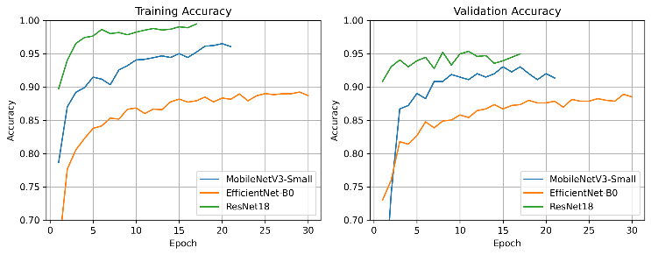
Fig. 1 - DFD training and validation accuracy for the three models.
- Test-Set Performance
The table below summarizes the DFD test results. Metrics are averaged over frame-level test set of 785 samples:
DFD Real-Time Performance
Model | Accuracy | Precision | Recall | F1-score
Train | 0.9019 | 0.8729 | 0.9381 | 0.9043
Val | 0.8777 | 0.8561 | 0.9046 | 0.8797
Test | 0.9248 | 0.8834 | 0.9768 | 0.9278

The corresponding confusion matrices are shown in Fig. 2.
MobileNetV3-Small: 344 TN, 53 FP, 24 FN, 364 TP. High recall for fake faces (93.8%) with moderate false positives on real images.
EfficientNet-B0: 338 TN, 59 FP, 37 FN, 351 TP. Both precision and recall are slightly lower than MobileNetV3-Small, consistent with under-adaptation.
ResNet18: 347 TN, 50 FP, 9 FN, 379 TP. The network misses very few fakes (FN rate 2.3%) and achieves the highest overall F1-score.
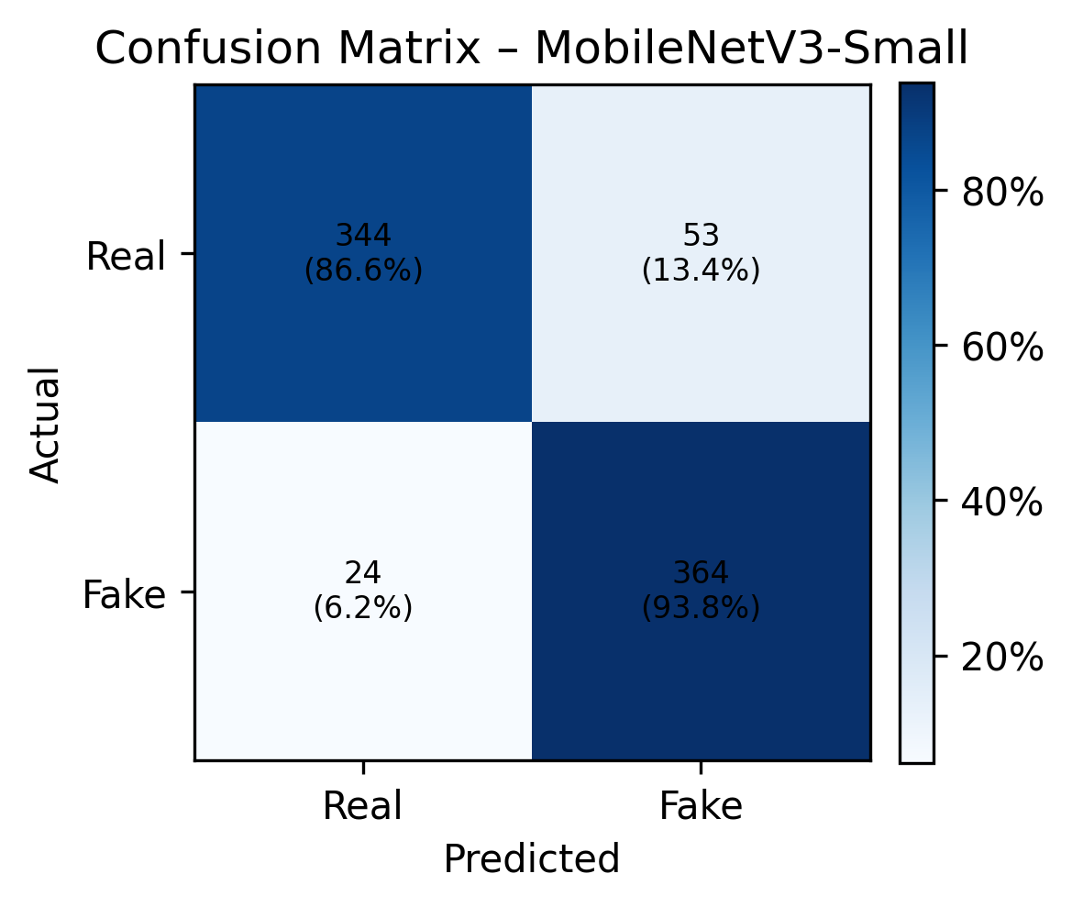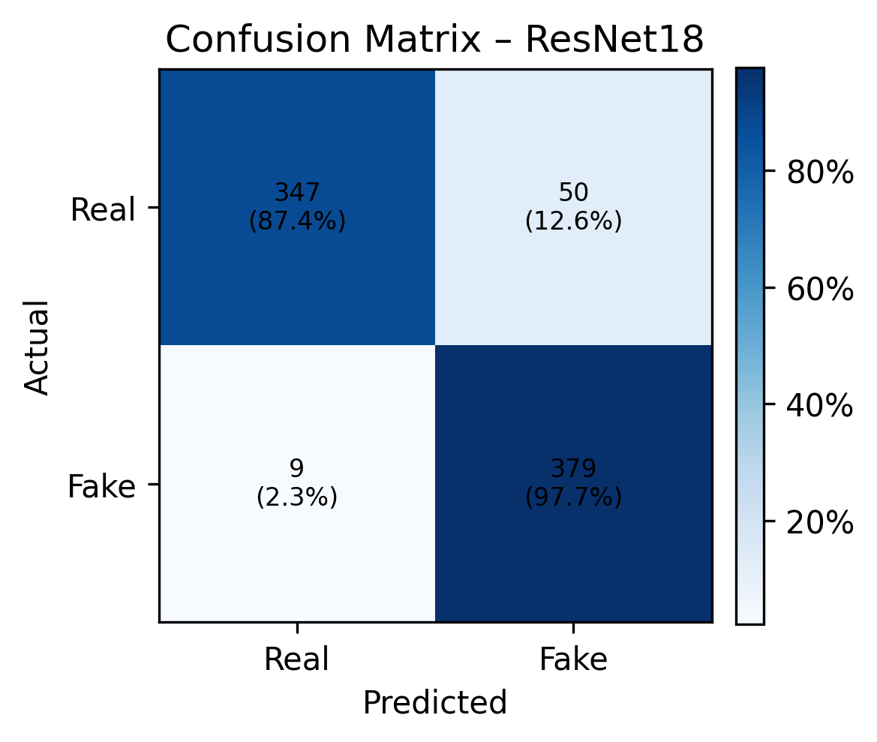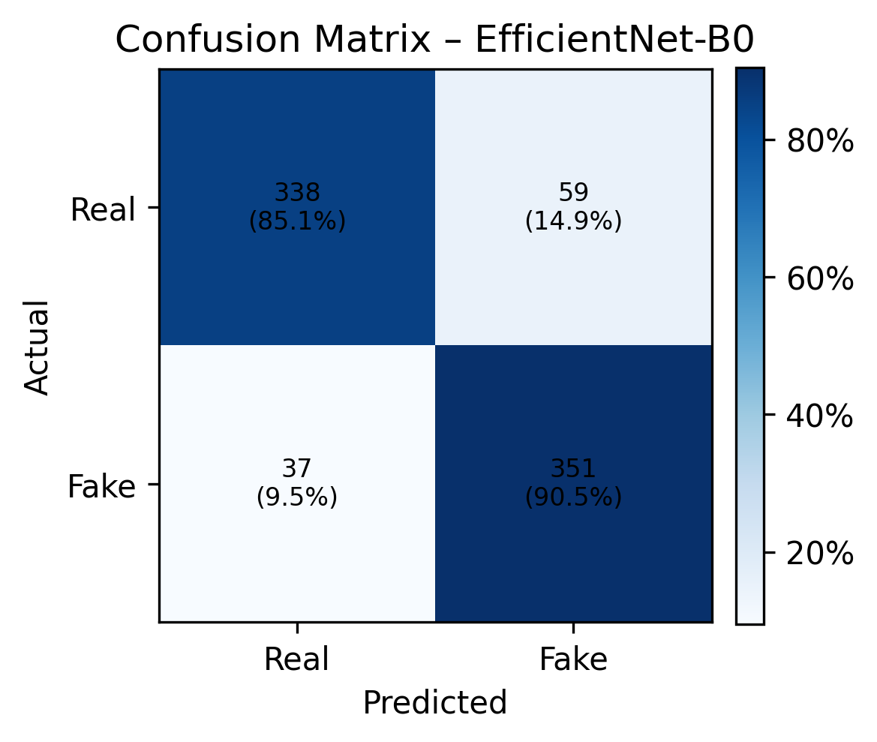
Fig. 2 - DFD confusion matrices for MobileNetV3-Small, ResNet18 and EfficientNet-B0
Fig. 3 presents a grouped bar chart of accuracy, precision, recall, and F1-score, highlighting that ResNet18 dominates across all metrics, while MobileNetV3-Small provides a close second with slightly lower recall but significantly fewer parameters.
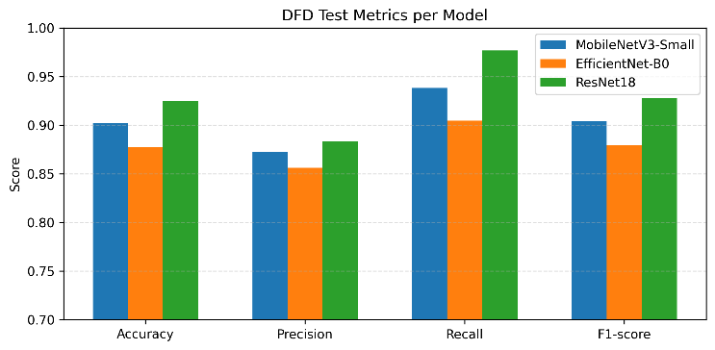Fig. 3 - DFD test metrics per model (accuracy, precision, recall, F1-score).
- Parameter Counts and Trainable Fraction
Fig. 4 visualizes total vs. trainable parameters (log-scale). As expected,:
MobileNetV3-Small: 1.52 M total, 0.59 M trainable (39%).
EfficientNet-B0: 4.01 M total, 2.6 k trainable (0.064%).
ResNet18: 11.18 M total, 8.40 M trainable (75%).

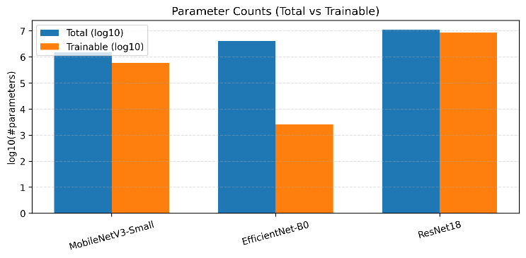Fig. 4 - DFD parameter counts: total vs. trainable parameters (log10 scale).
The main reason why ResNet1 has strong performance is because of higher trainable capacity. Also, there is a huge difference between EfficientNet-B0 and MobileNetV3. Despite having more parameters in EfficientNet-B0, it is weaker than MobileNetV3 in performance because the layers are almost frozen.
- Real-Time Performance
By averaging inference time over the test frames, the study measured latency and throughput on a single GPU. The results are in the table and visualized in the Figs. 5-6 below:
DFD Real-Time Performance
Model | Avg Latency (ms / frame) | Throughput (FPS)
MobileNetV3-Small | ≈0.53 | ≈1904
EfficientNet-B0 | ≈1.04 | ≈966
ResNet18 | ≈0.84 | ≈1188

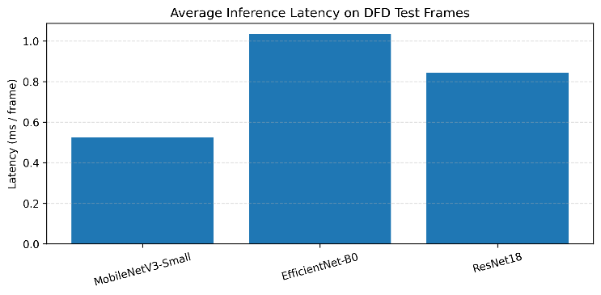Fig. 5 – DFD average inference latency per model.
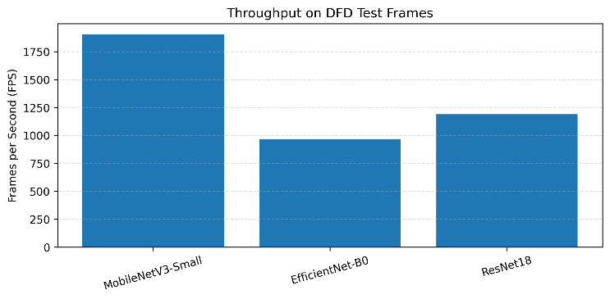Fig. 6 – DFD throughput (frames per second) per model.
All these models can easily exceed real-time requirements, like more than 30 FPS. The fastest one is MobileNetV3-Small, however the balanced and compromised model is ResNet18 with higher accuracy and FPS
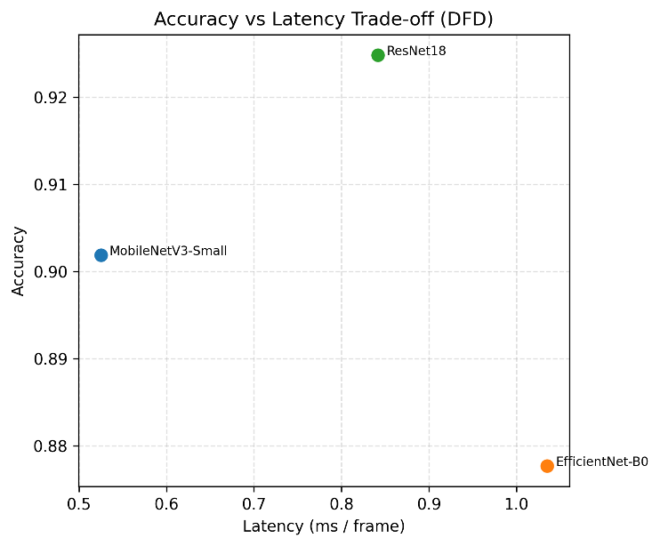Fig. 7 – DFD accuracy vs. Latency trade-off

- Discussion (DFD)
All three architectures achieve >0.87 accuracy on the small and less challenging DFD dataset. The followings are outputs from the results:
- Even though ResNet18 is a heavier model, the higher trainable capacity and residual learning results with the best F1 score and recall.
- MobileNetV3-Small achieved high recall because of the benefits of SE attention and residual blocks.
- Because of the frozen backbone, EfficientNet-B0 underperforms in its scores although it is focused on smart and sophisticated scaling strategy

VI. EXPERIMENTS ON THE CELEB-DF v2 DATASET
Now it is time to move to the more challenging Celeb-DF v2 dataset with diverse and higher quality deepfakes
- Learning Dynamics
Fig. 8 shows training and validation of accuracy curves on Celeb-DF v2.
ResNet18 again converges rapidly, surpassing 0.90 validation accuracy in the first epoch and reaching a maximum validation accuracy of 0.991 at epoch 29, with final train accuracy of 0.989. The train–val gap is negligible (≈0.2 pp), indicating excellent generalization on this large dataset.
MobileNetV3-Small improves more slowly, with validation accuracy rising from 0.74 to a maximum of 0.876 by epoch 29. Interestingly, validation accuracy slightly exceeds training accuracy (negative gap ≈2 pp), likely due to strong augmentation and the stochastic nature of batch statistics.
EfficientNet-B0 saturates early at around 0.75 training and validation accuracy, showing clear under-fitting with the frozen backbone.
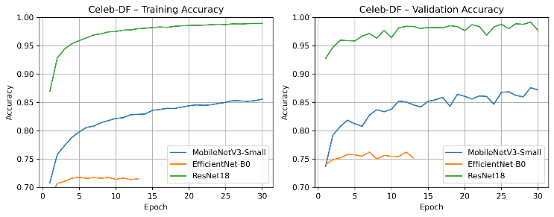Fig. 8 – Celeb-DF v2 training and validation accuracy for the three models.
- Test-Set Performance
Celeb-DF v2 test metrics are reported in Table below and visualized in Fig. 9.

DFD Real-Time Performance
Model | Acc | Precision | Recall | F1-score
MobileNetV3-Small | 0.8737 | 0.8549 | 0.9011 | 0.8774
EfficientNet-B0 | 0.7590 | 0.7408 | 0.7989 | 0.7688
ResNet18 | 0.9891 | 0.9952 | 0.9830 | 0.9891

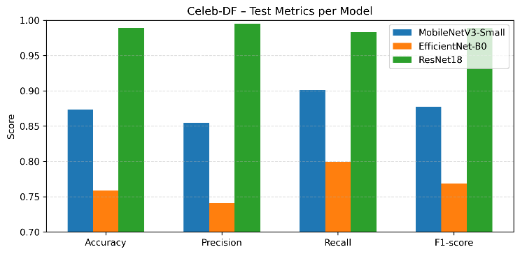Fig. 9 – Celeb-DF v2 test metrics per model (accuracy, precision, recall, F1-score).
The corresponding confusion matrices are shown in Fig. 2.
MobileNetV3-Small: 4 261 TN, 775 FP, 501 FN, 4 566 TP. Compared to DFD, both FP and FN counts are higher, reflecting the increased difficulty of Celeb-DF.
EfficientNet-B0: 3 620 TN, 1 416 FP, 1 019 FN, 4 048 TP. The model struggles to separate real and fake faces, consistent with its low adaptivity.
ResNet18: 5 012 TN, 24 FP, 86 FN, 4 981 TP. Errors are extremely rare: FP rate = 0.5%, FN rate = 1.7%.
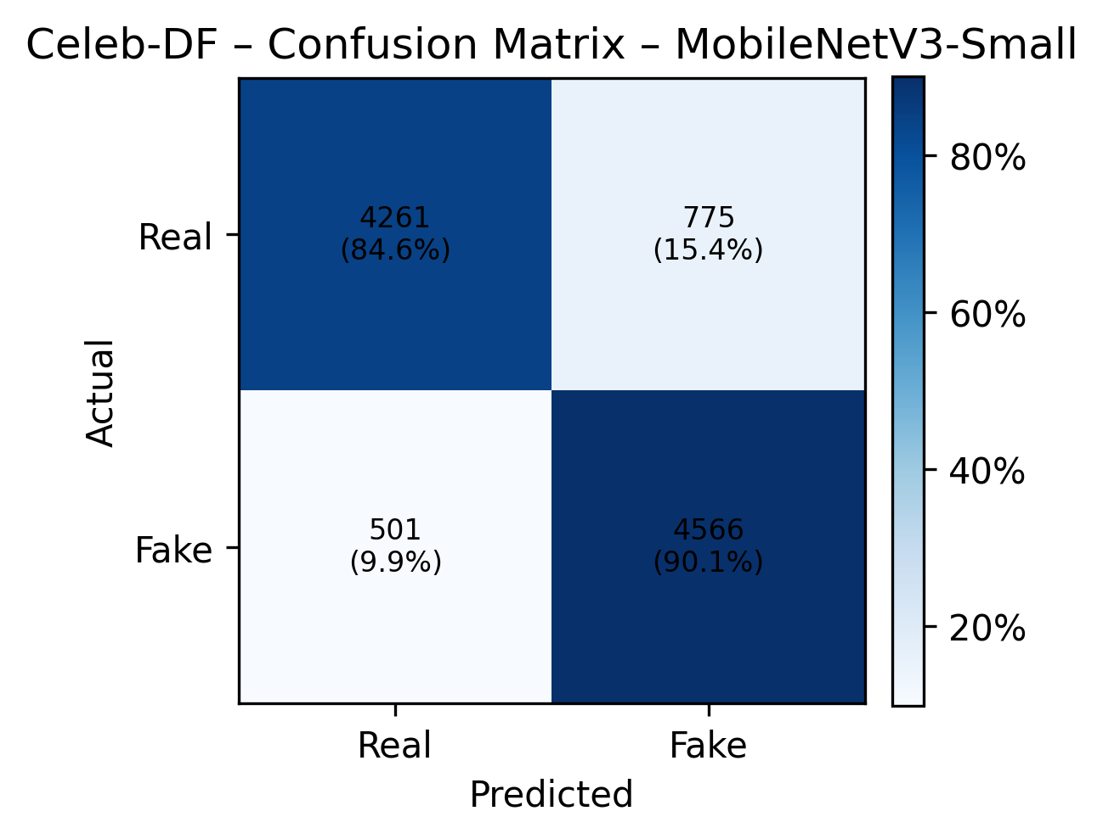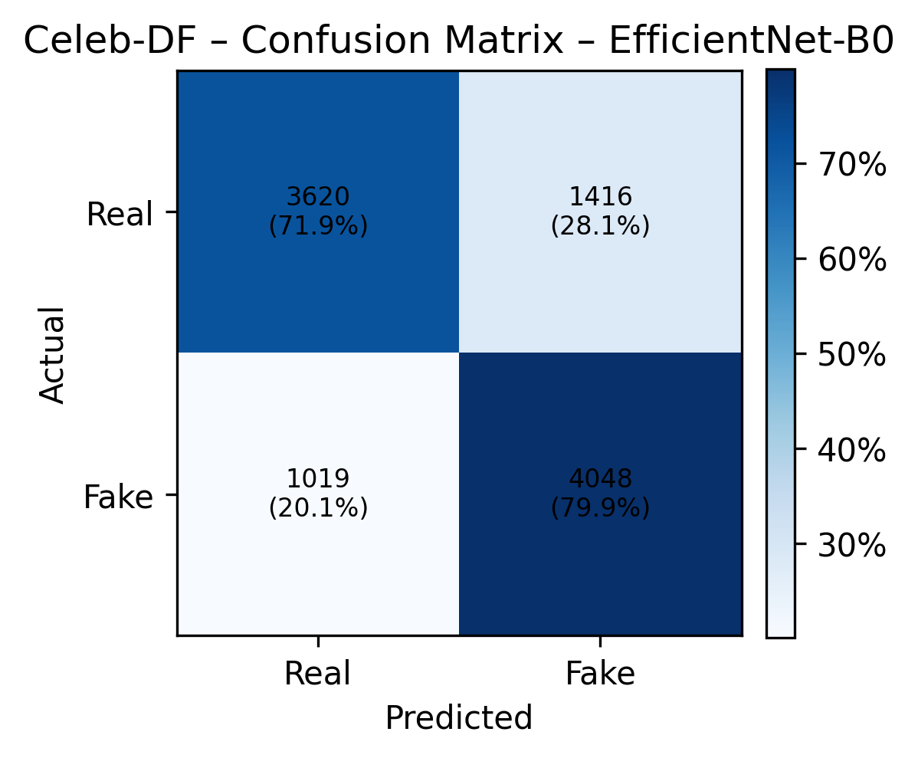
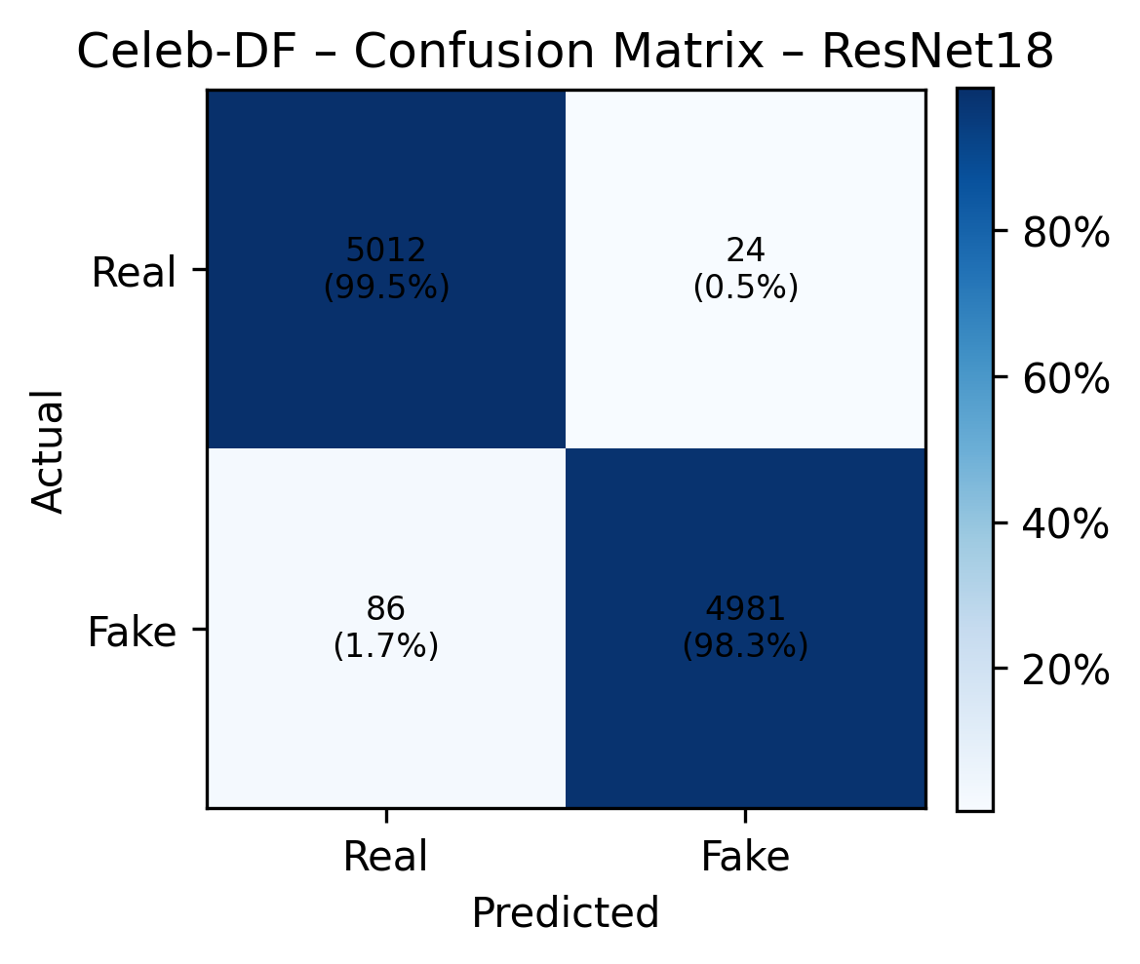
Fig. 10 – Celeb-DF v2 confusion matrices for MobileNetV3-Small, EfficientNet-B0, MobileNetV3-Small, and ResNet18.
Obviously, ResNet18 improves from 92.5% accuracy on DFD to 98.9% on Celeb-DF v2. This is because of its large training set and capacity

- Parameter Counts
As it is visualized in Fig. 11, Celeb-DF v2 parameter counts are identical to DFD, because architectures are unchanged
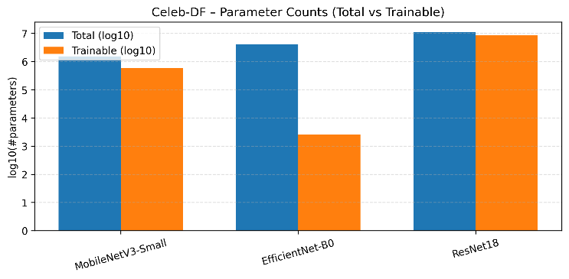Fig. 11 – Celeb-DF parameter counts: total vs. Trainable parameters (log10 scale)
- Real-time Performance
DFD Real-Time Performance
Model | Avg Latency (ms / frame) | Throughput (FPS)
MobileNetV3-Small | ≈0.35 | ≈2844
EfficientNet-B0 | ≈0.98 | ≈1023
ResNet18 | ≈0.73 | ≈1375

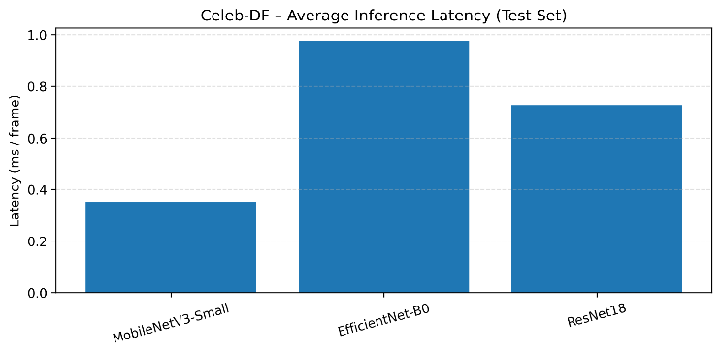Fig. 12 – Celeb-DF v2 average inference latency per model
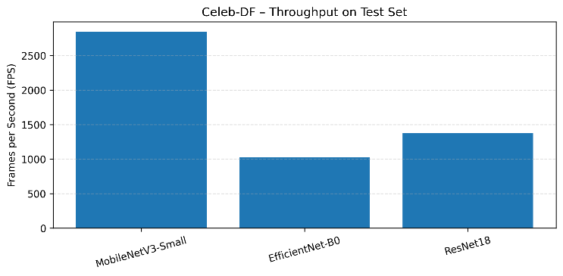Fig. 13 – Celeb-DF v2 throughput (frames per second) per model
Fig. 14 plots of accuracy against latency. ResNet18 again lies near the optimal frontier but with much higher accuracy than on DFD. MobileNetV3-Small remains the fastest model with acceptable accuracy for some practical scenarios.
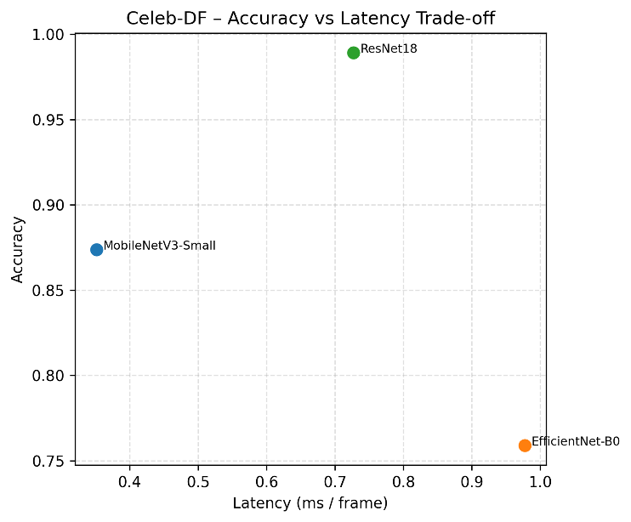Fig. 14 – Celeb-DF v2 accuracy vs. Latency trade-off

- Discussion (Celeb-DF v2)
As mentioned previously, this dataset is more challenging than DFD. The deepfakes in this dataset is generated with very few visible artifacts. Also, it is produced using high-quality synthetic pipelines. Therefore, this dataset clearly reveals differences between architectures:
ResNet18 is proved that its high trainable capacity to learn high-frequency and subtle artifacts that lead to perfect detection performance
MobileNetV3-Small is also good balanced architecture with its focus on speed-accuracy balance, however its limited depth and channel width is not better for subtle artifacts. This model's accuracy saturates around 87%
EfficientNet-B0 is the worst one and clearly underfitted. The backbone features are not suitable for specialized deepfake cues. Only the last 2.6K parameters updated and other backbone features are so weak for challenging deepfakes. Both precision and recall remain below 0.80

VII. CROSS-DATASET AND ARCHITECTURAL ANALYSIS
A. Dataset Difficulty versus Model Capacity
In this section, the study will compare DFD and Celeb-DF to reveal how the difficulty of dataset and model capacity interacts:
DFD → Celeb-DF change.
MobileNetV3-Small: accuracy slightly decreases from 90.2% (DFD) to 87.4% (Celeb-DF v2).
EfficientNet-B0: accuracy drops from 87.8% to 75.9%.
ResNet18: Accuracy increases from 92.5% to 98.9%.
This pattern proposes that the larger and realistic datasets augment the importance of residual learning and the training capacity and explose some limitations related to low capacity or frozen models.

B. Architectural Factors
Now, in this section, the study focuses on architectural features that can strongly influence performance
- Residual Connections (ResNet18)
Residual blocks provide identity shortcuts that preserve low-level information and ease gradient flow during training. These residual blocks are the main components for detecting subtle manipulations without overfitting, specifically beneficial for Celeb-DF v2. Also the strong F1-scores and stable curves accross datasets are main results or strength of ResNet18’s residual learning and its robustness
- Inverted Residuals and Depth wise Convolutions (MobileNetV3-Small)
The reduced FLOPs and reduced parameters MobileNetV3 are a product of depth-wise separated convolutions and inverted residual structures. MobileNetV3 also includes SE blocks which help represent local texture artifacts achieving positive nearby recall and F1-Score results on DFD. Due to having a lower overall channel capacity, however, the more complex Celeb-DF v2 may limit MobileNetV3 performance as a global context, and more nuanced color and lighting facials play a more dominant role.
- Compound Scaling with Frozen Backbone (EfficientNet-B0).
The ability of EfficientNet is to scale depth, width, and resolutions jointly. Here, the study conducts training that focuses only on the classifier. Thus, the model linearly classifies features from ImageNet, which are not tuned for deep-fake artifacts. This is why EfficientNet-B0 is the heaviest model in terms of latency in comparison, because it achieves the lowest performance.
- Trainable Fraction and Overfitting Gap.
ResNet18 (75% trainable) is distinguishable with its highest accuracy on both 2 of the datasets with balanced overfitting gaps (<42 pp). The next model is MobileNetV3-Small with 39% trainable parameters. This model achieved slightly lower accuracy, however, remains balanced and robust. EfficientNet-B0 (0.064% trainable) shows almost no overfitting but clear under-fitting on both datasets. This confirms that deepfake detection is highly corresponded with training fraction, especially on high-quality datasets with high-fidelity
C. Real-Time Trade-offs
Across both datasets all models substantially exceed real-time requirements. Nevertheless, the exact trade-off differs:
- Best Accuracy: ResNet18 – suitable for back-end verification servers and GPU-equipped workstations, or single-stream real-time monitoring where accuracy is critical.
- Best Speed: MobileNetV3-Small – ideal for resource-constrained edge devices, mobile phones, or multi-stream systems where hundreds of video streams must be processed in parallel.
- Inefficient Mode: In our configuration, EfficientNet-B0 represents a sub-optimal point: slower than MobileNetV3-Small, less accurate than both, and limited by the frozen backbone.
VIII. CONCLUSION AND FUTURE WORK
This paper presented a comparative analysis of three lightweight CNN architectures—MobileNetV3-Small, EfficientNet-B0, and ResNet18—for real-time deepfake detection on face-level frames. Using a unified preprocessing and training pipeline, we evaluated the models on two datasets: a frame-level DFD subset and the large Celeb-DF v2 image dataset.
Key findings are:
- ResNet18 consistently achieves the best detection performance, reaching 92.5% accuracy on DFD and 98.9% on Celeb-DF v2, while still operating at over 1 k FPS on GPU.
- MobileNetV3-Small offers the best speed–accuracy balance, with ~1.9–2.8 k FPS and F1-scores around 0.90 on DFD and 0.88 on Celeb-DF v2, making it attractive for deployment on edge devices.
- EfficientNet-B0, when used with a frozen backbone and only a trainable classifier head, underperforms on both datasets, demonstrating that deepfake detection requires backbone fine-tuning rather than simple linear probing.
- Architectural properties—residual connections, inverted residual blocks, squeeze-and-excitation, and especially the fraction of trainable parameters
REFERENCES
1. A. Rossler et al., “FaceForensics++: Learning to Detect Manipulated Facial Images,” Proc. ICCV, 2019. CVF Open Access
2. Y. Li et al., “Celeb-DF: A Large-scale Challenging Dataset for DeepFake Forensics,” Proc. CVPR, 2020.
3. Google/Jigsaw, “DeepfakeDetection Dataset,” 2019. ResearchGate
4. A. Howard et al., “Searching for MobileNetV3,” Proc. ICCV, 2019.
5. M. Tan and Q. Le, “EfficientNet: Rethinking Model Scaling for Convolutional Neural Networks,” Proc. ICML, 2019.
6. K. He, X. Zhang, S. Ren, and J. Sun, “Deep Residual Learning for Image Recognition,” Proc. CVPR, 2016.
7. J.-H. Lee and S.-H. Kang, “MobileNet-Based Lightweight Deepfake Detection Model with Model Compression,” Journal of KIIT, 2022. KCI

